+ Rate of Reactions, p594.
- How can you express the rate of a chemical reaction?
- Factors Affecting Reaction Rates
2.1 Explain how and why a catalyst affects reaction rates
2.2 Explain how and why temperature affects reaction rates
2.3 Explain how and why surface area affects reaction rates
2.4 Explain how and why concentration affects reaction rates
  - Explain how and why pressure affects reaction rates
- Use the diagram below to develop the relation between energy diagrams and endothermic or exothermic reactions
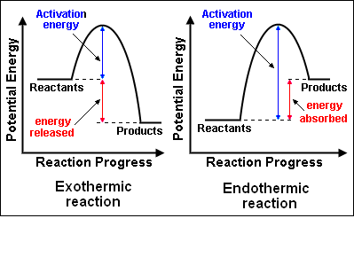
+ Equilibrium, p609:
- Explain why the reaction between sulfur dioxide and oxygen to yield sulfur trioxide is considered a reversible reaction. Write the corresponding equation.
- Summarize briefly how the factors affecting equilibrium: Concentration, Temperature, Pressure, Catalyst.
- Write the expression of the equilibrium constants for the following reactions: PCl_{5(g)} → PCl_{3(g)} + Cl_{2(g)} and
C_{(s)} + H₂O _{(g)} → CO_{(g)} + H₂ _{(g)}
- How the equilibrium position of this reaction affected by the following changes? 2SO₂(g) + O₂(g) → 2SO₃(g) + heat
a) lowering the temperature b) decreasing the pressure c) removing oxygen d) adding sulfur trioxide, SO₃.
- The reaction in which ammonia is formed is N₂(g) + 3H₂(g) ↔ 2NH₃(g) At equilibrium a 1Liter flask contains 0.15 mol H₂, 0.25 mol N₂ and 0.10 mol NH₃. Calculate K_{eq}.
- In problem 5; does the mixture at equilibrium consists mainly of reactants or products? Explain.
- Suppose the following system reaches equilibrium: N₂(g) + O₂(g) ↔ 2NO(g) If the concentrations of the substances are, respectivesly, 0.50 mol/L, 0.50 mol/L and 0.02 mol/L, calcule K_{eq}.
- At a given temperature, the equilibrium constant for the following reaction is 5.6
2NO₂(g) ↔N₂O₄(g) Given that the conc of N₂O₄(g) is 0.66 mol/L, what is the equilibrium conc of NO₂?
- Hydrogen iodide decomposes as follows: 2HI(g) ↔ H₂(g) + I₂(g) If in a 1 liter container at 450ºC the mixture contains 0.50 mol of H₂, what is the equilibrium concentration of HI (g)? Keq = 0.02

